**For doing projects at home:**

**This was made with Windows but should look similar for Mac**

Install python for your machine from <https://www.python.org/downloads/>

Install github desktop from <https://desktop.github.com/>

Open github desktop and enter your credentials

**To clone a repository**

In your online repository:

Click: code -> open with github desktop

In github desktop a window should appear

DON’T ALTER THE URL

DO alter the path you want the local repository to appear at (I recommend you store all of your 168 labs in the same folder)

**To send changes to your online repository:**

In github desktop: make sure you’re looking at the correct repository in the top left corner



Type a short summary of your changes in the small window and click: commit to main

Now click the “push origin” button

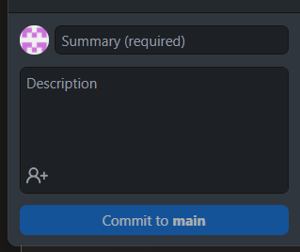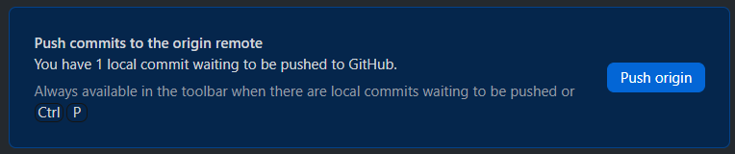

Click: view on github to make sure everything is up to date online.